3.1 – 3.5 Review Worksheet (In-Class)

- State the domain for the function and create a picture of the domain in the xy-plane.
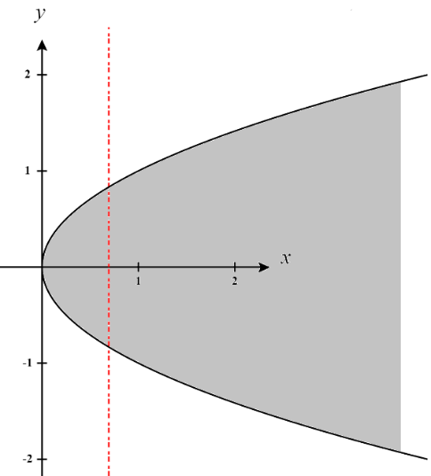
We see that for this function to be defined. Therefore, we define the domain as: . A picture of this domain is shown at the right (notice that we have excluded all points on the line .

- Determine each of the following limits or show that it does not exist.

We note that we are computing the limit of a rational function here which is continuous at , therefore

If we approach along the path we see that
If we approach along the path we see that
This implies that the limits across all paths are not the same and therefore the limit DNE.

If we approach along the path we see that
If we approach along the path we see that

This implies that the limits across all paths are not the same and therefore the limit DNE.

- Suppose that a function is continuous over all of and has the following properties. First suppose that for any point it is the case that . Second suppose that the following points exist on the surface created by :
Use this information to determine the exact value of the limit .

Since we are told that is continuous over all of we know that .
Based on the first property we are told about the function we know that .
Then, based on the list of points given we know that .
Therefore, we have that

- Compute each of the indicate partial derivatives for the function .
- Find .

- Find

First note that .
Then we calculate that

- Like in the last question, consider the function
- Show that the function is differentiable at the point .

We note from the previous question that
and .
We see that these partial derivatives exist and are continuous at the point . Therefore, is differentiable at .

- Find a point where we cannot guarantee that the function is differentiable.

We see that these partial derivatives do NOT exist at the point , since . Therefore, is not necessarily differentiable at .

- Determine for the surface given by the equation
We proceed by taking the partial derivative with respect to y implicitly.

- Suppose that . Find when .

We know that
Therefore,

- Suppose that , , and . Find when .

We know that
Therefore,

- A manufacturer has modeled its yearly production function P (the value of its entire production in millions of dollars) by the function . L represents the number of labor hours (in thousands) and K represents the invested capital (in millions of dollars). Suppose that when and , the labor force is decreasing at a rate of 2000 labor hours per year and the capital is increasing at a rate of $500,000 per year. Find the rate of change of production. Round your final answer to 3 decimal places.

We want to find and from the chain rule we know that .

Therefore, we know that

